## **QUERY PERFORMANCE DASHBOARD**

# **Snowsight Dashboard Setup**

### **1 TOTAL QUERIES**

select count(*) from snowflake.account_usage.query_history;

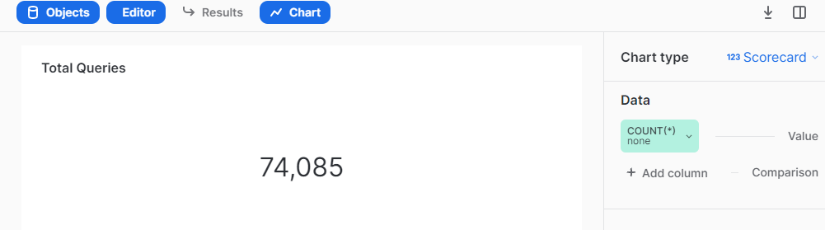

### 

### **2 AVERAGE QUERY RUNTIME IN MILLISECONDS**

SELECT ROUND(AVG(TOTAL_ELAPSED_TIME),2) AS AVG_PERFORMANCE FROM snowflake.account_usage.query_history ;

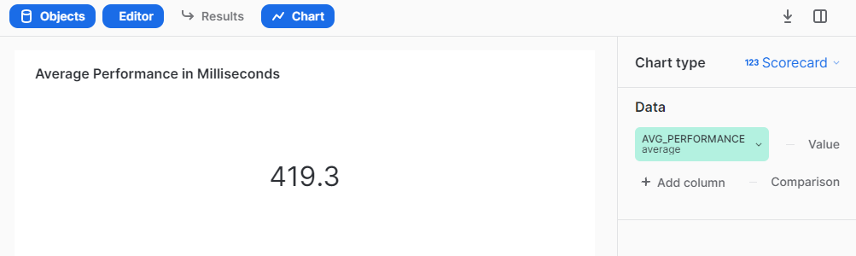

### 

### **3 QUERIES USING CLOUD SERVICE LAYER**

select count(warehouse_size) as csl_count from ( select IFNULL(WAREHOUSE_SIZE,'NO WAREHOUSE') AS WAREHOUSE_SIZE,warehouse_name,query_id,query_text from snowflake.account_usage.query_history where warehouse_size IS NULL);

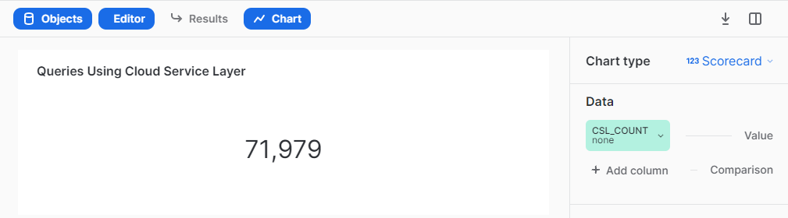

### 

### **4 CLOUD SERVICE LAYER UTILIZATION RATE**

select CONCAT(ROUND(CSL_UTILISATION,2), '%') AS CSL_UTILISATION_RATE FROM

(SELECT

(select count(warehouse_size) as csl_count from ( select IFNULL(WAREHOUSE_SIZE,'NO WAREHOUSE') AS WAREHOUSE_SIZE,warehouse_name,query_id,query_text from snowflake.account_usage.query_history where warehouse_size IS NULL)) /

(SELECT count (IFNULL(warehouse_size,'NO WAREHOUSE')) from snowflake.account_usage.query_history) * 100 AS CSL_UTILISATION );

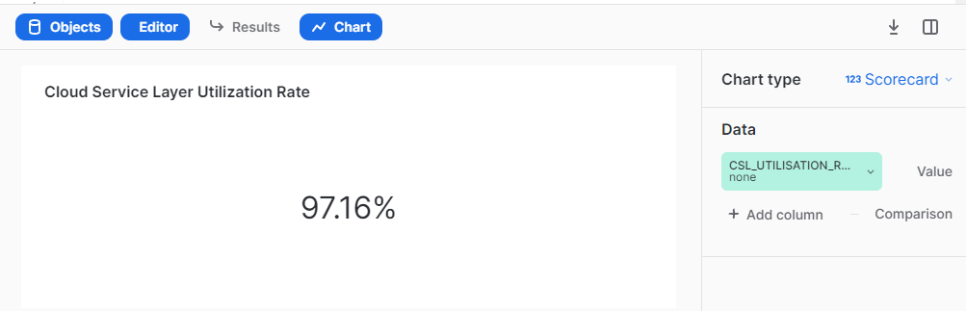

### 

### **5 QUERIES BY WAREHOUSE**

select IFNULL(WAREHOUSE_NAME, 'CSL') AS WAREHOUSE_NAME, IFNULL(WAREHOUSE_SIZE, 'CACHE') AS WAREHOUSE_SIZE from snowflake.account_usage.query_history;

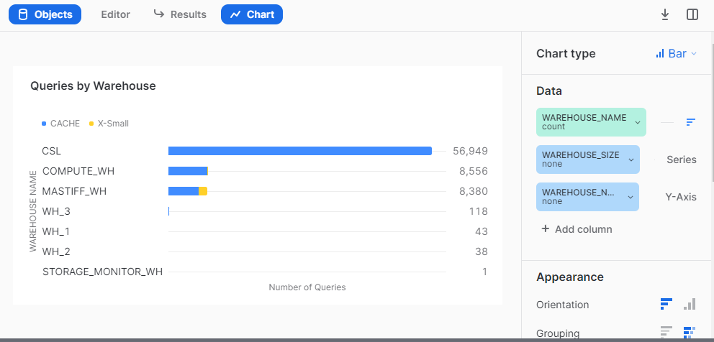

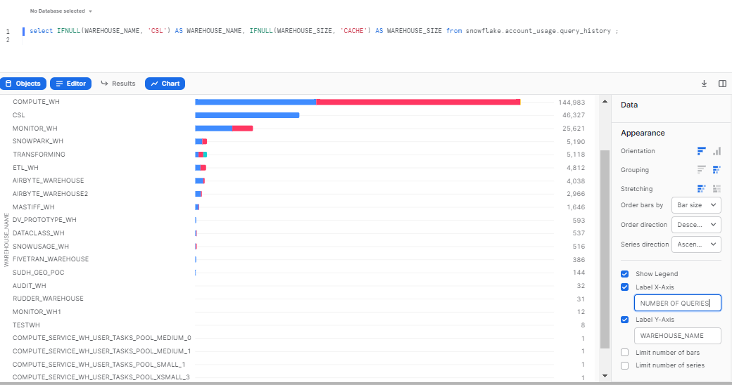

### 

### **6 QUERIES PER WAREHOUSE SIZE**

select IFNULL(WAREHOUSE_SIZE,'NO WAREHOUSE') AS WAREHOUSE_SIZE,* from

Snowflake.account_usage.query_history;

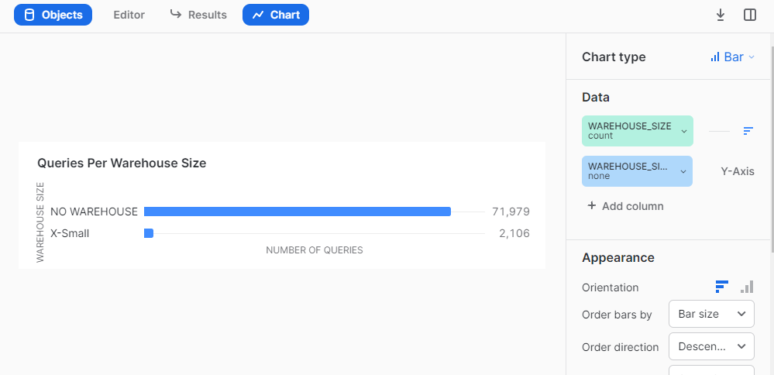

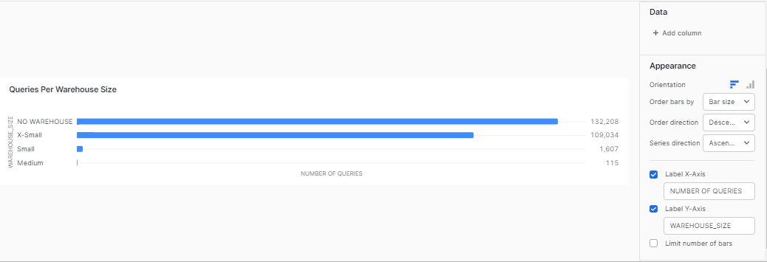

### 

### **7 QUERIES BY DATABASE**

select IFNULL(database_name,'NO DATABASE') AS DATABASE_NAME, IFNULL(WAREHOUSE_SIZE, 'CACHE') AS WAREHOUSE_SIZE, WAREHOUSE_NAME, ROLE_NAME from snowflake.account_usage.query_history ;

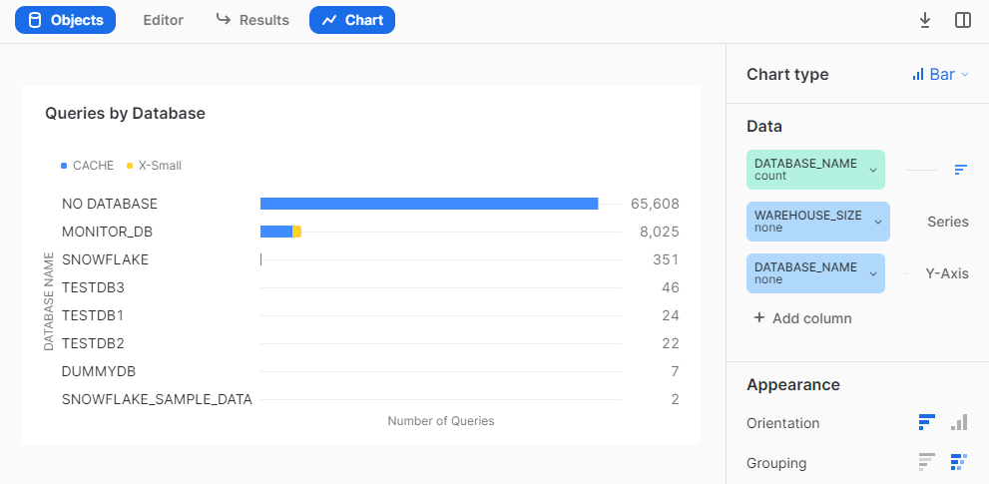

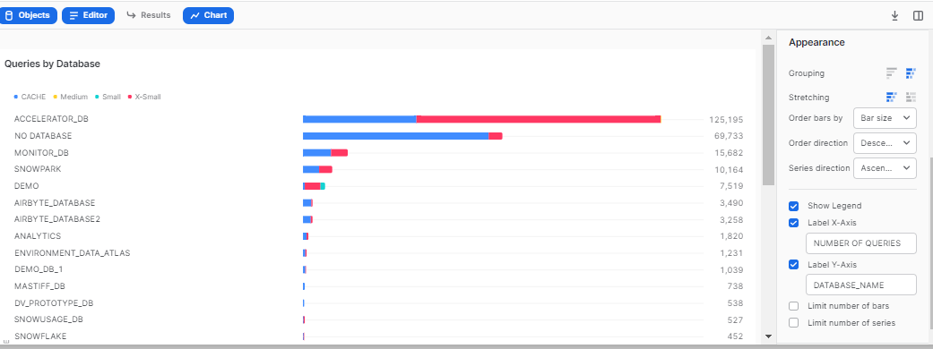

### 

### **8 QUERIES BY SCHEMA**

select IFNULL(SCHEMA_NAME,'NO SCHEMA') AS SCHEMA_NAME, IFNULL(WAREHOUSE_SIZE, 'CACHE') AS WAREHOUSE_SIZE, WAREHOUSE_NAME, ROLE_NAME from snowflake.account_usage.query_history ;

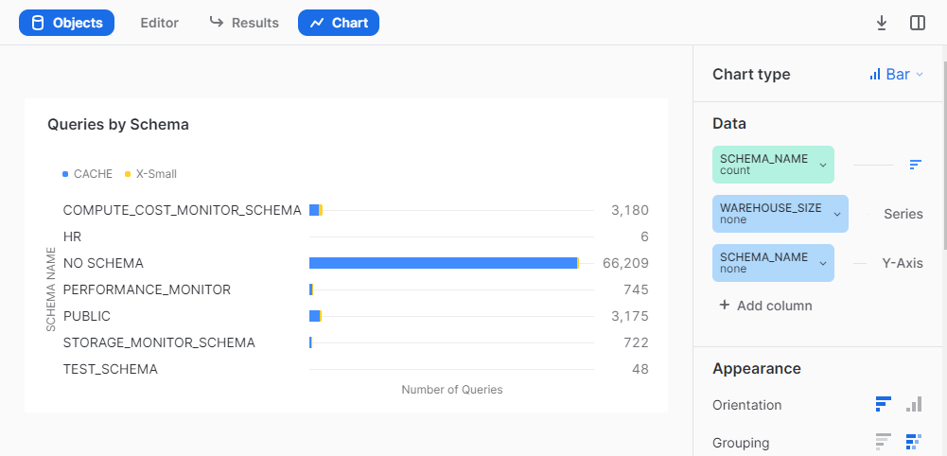

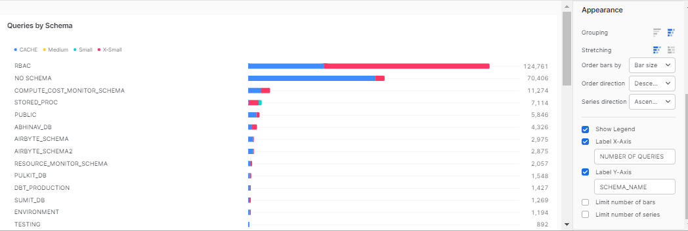

### 

### **9 AVERAGE TIME METRIC OVER TIME**

select * from snowflake.account_usage.query_history;

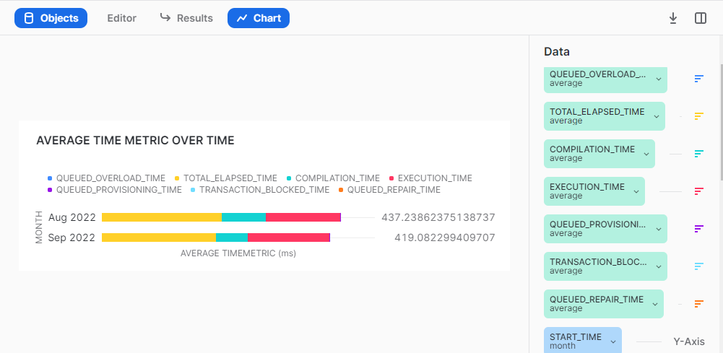

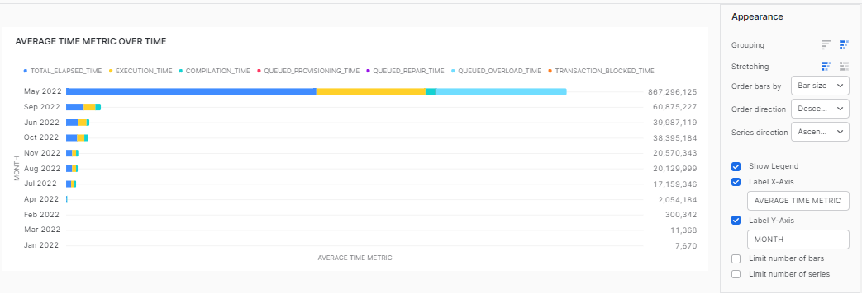

### 

### **10 AVERAGE TIME METRIC PER BYTE SCANNED**

select top 9000 compilation_time,execution_time,queued_provisioning_time,queued_repair_time,queued_overload_time,total_elapsed_time,transaction_blocked_time,bytes_scanned from snowflake.account_usage.query_history ;

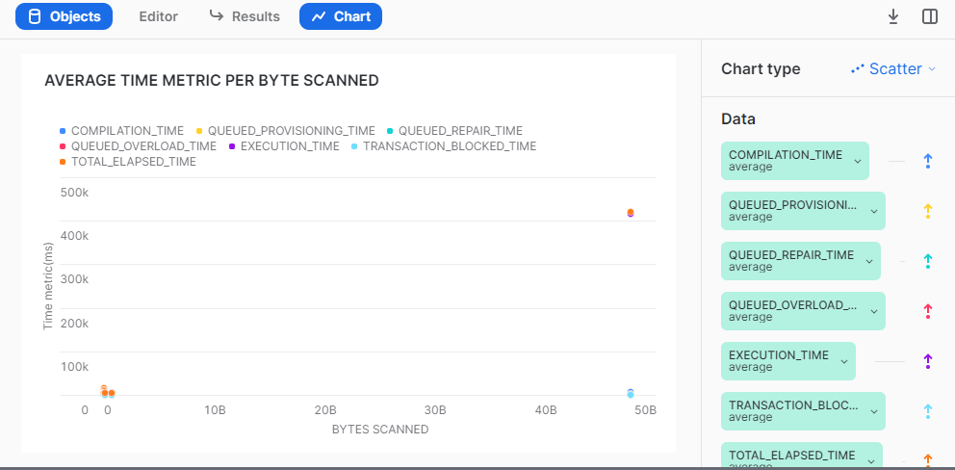

### 

### **11 AVERAGE TIME METRIC PER WAREHOUSE SIZE**

select IFNULL(WAREHOUSE_SIZE,'NO WAREHOUSE') AS WAREHOUSE_SIZE,* from

snowflake.account_usage.query_history;

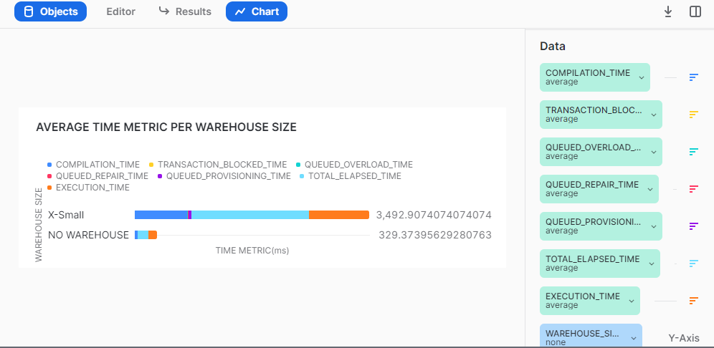

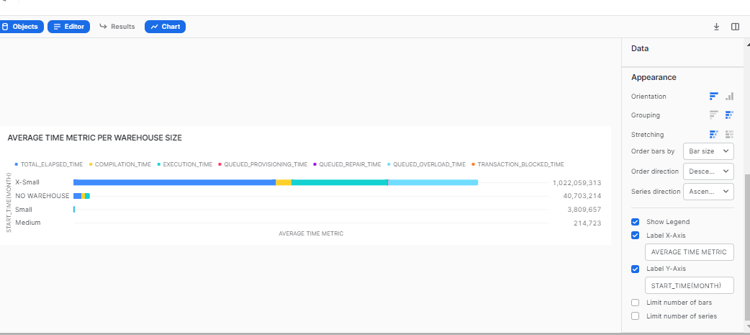

### 

### **12 AVERAGE DURATION BY DATABASE**

select IFNULL(WAREHOUSE_SIZE,'NO WAREHOUSE') AS WAREHOUSE_SIZE, IFNULL(DATABASE_NAME,'NO DATABASE') AS DATABASE_NAME,

* from snowflake.account_usage.query_history;

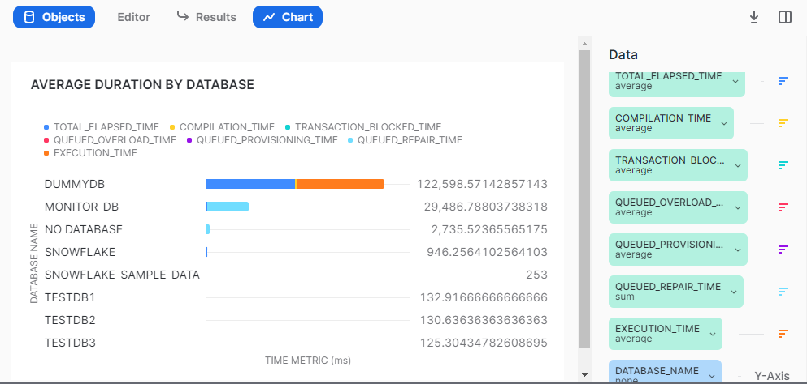

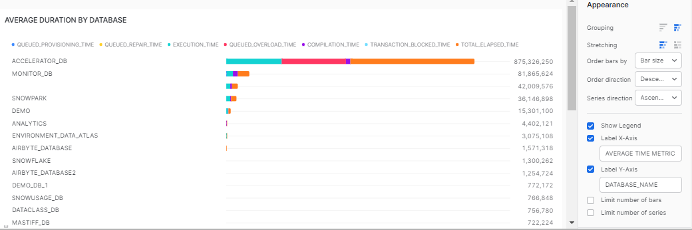

## **Best Practices -**

* If you have records more than 10000 then select only top 9999 ( refer. link:- <https://docs.snowflake.com/en/sql-reference/constructs/top_n.html>) to create a chart as Snowsight only supports data to be visualized till 9999 rows.
* It's preferable to do aggregation in the query itself rather than to do it in Snowsight UI.
* Adjust the round off value as per your requirement ( e.g - round((<column_name>), n) where n = natural number ).
* On hovering over any filter, visuals getting filtered would be highlighted.
* To make filter interaction more user friendly, you can even use color coding.
* If snowsight dashboard is running slow, then to optimize performance:
  + It is recommended to extract only three months (or less than three months) data from the query history using a date range filter in all the KPIs.

For example - select count(*) from snowflake.account_usage.query_history where start_time = :daterange;

* + Utilize a custom table to store the latest three months (or less) of query history data, allowing you to leverage it for the query performance dashboard.

## 